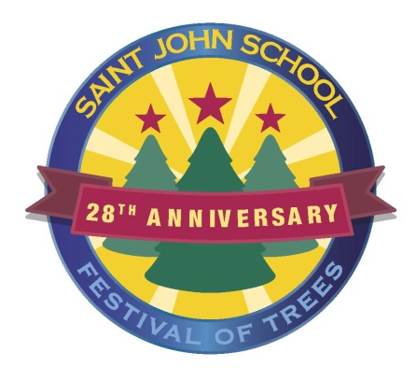
Twelve Days of Festival of Trees - Sponsorship Levels

____ 12 Drummers Drumming Sponsorship - $12,000 Includes special event signage on all of our social media platforms for the month of November, verbal recognition during the live event, twenty 50/50 tickets, , 10 prime rib dinners to-go on the evening of November 27, a mystery wine bottle and a large box of Christmas cookies and a chance for a $500 sponsor raffle.. Only one of these sponsorship levels is available.

____ 10 Lords-a-Leaping Sponsorship - $10,000 Includes special recognition on all social media platforms, verbal recognition during the live event, ten 50/50 tickets, a bottle of mystery wine, 8 prime rib dinners to-go on the evening of November 27, a large tray of Christmas cookies and a chance for a $500 cash sponsor raffle.. Only one of these sponsorship levels is available.

____ 5 Golden Rings - $5,000 Includes verbal recognition during the live event, prominent recognition on all social media platforms, ten 50/50 tickets, a bottle of mystery wine, 6 prime rib dinners to-go on the evening of November 27, a large box of Christmas cookies and a chance for a 4500 sponsor cash raffle. Only three of these sponsorship levels are available.

____ 3 French Hens - $3,500 Includes recognition on our preferred social media platform, a bottle of mystery wine, 6 prime rib dinners to-go on the evening of November 27, a box of Christmas cookies and a chance for a $500 sponsor cash raffle. Only 4 of these sponsorship levels are available.

____ 2 Turtle Doves - $2,000 Includes recognition on social media, 4 prime rib dinners to-go on the evening of November 27 a box of Christmas cookies and a chance for a $500 sponsor cash raffle.

____ A Partridge in a Pear Tree - $1,000 Includes recognition on social media, and a dinner package of two prime dinners, a bottle of mystery wine, a cookie tray and a ticket for a special raffle for $500 cash.

____ My True Love Gave to Me - $500 Includes recognition on social media and four 50/50 tickets.

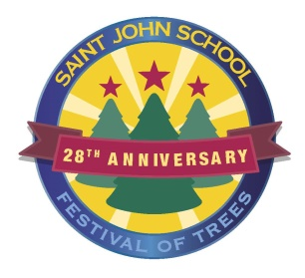

An Item for the Auction or a Cash Donation

___ I will be a sponsor at the following level __________________________

_____ I will donate the following item for the auction: _______________________________________

Valued at: _____________________________________________________________________

_____ Please accept the enclosed cash donation for the Festival of Trees to be used at your discretion.

_____ Please contact me regarding a donation for the auction. __________________________________

All Sponsors and Donors, please complete the following:

Name ______________________________________________________________________________

As you would like it listed in our program

Address ____________________________________________________________________________

Phone #______________________________ Email _________________________________________

In order to acknowledge your contribution to The 12 days of Festival of Trees,
please e-mail your company logo to fot21@sjheralds.org by October 30, 2021.

